Title (official language: English)
Name Surname,ª Name Surname,^{b} …, and Name Surname^{b}
ª Affiliat. to be expressed in this way: Dept, Institute, Address, ZIP/CAP-City, Country
^{b} Affiliat. to be expressed in this way: Dept, Institute, Address, ZIP/CAP-City, Country
E-mail: (of the presenting author, who must be the first author)

Abstract text here. Font: Times New Roman, 13. Line spacing: 1.5.
0.5 cm indentation when starting a new line.
References must be introduced in the text in this way [1], before the punctuation mark and between square brackets [2].
One page only!
Save the file with this name: ABS-Surname.Name (of the first author).
Send the abstract before September 28th 2014 to federico.bella@polito.it and domenico.spinelli@unibo.it

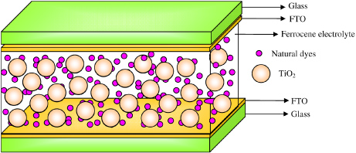
Figure 1: Caption here

References:
[1] N. Surname, N. N. Surname and N. Surname, Abbreviated journal title VOL (year) pag-pag.
[2] N. Surname, N. N. Surname and N. Surname, Abbreviated journal title VOL (year) pag-pag.

